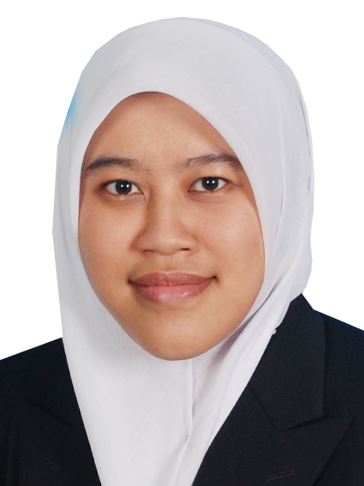
NOR ASHIKIN BINTI DALIB
Lot 1350 D10 Lorong Haji Salam
Sungai Pinang 41400 Klang
Selangor Darul Ehsan
Malaysia
HP: 017-3379439
shikindalib@yahoo.com

Objective

I want to become a productive employee to the organization that I serve by achieving the goals of the organization with the motto ‘Increase profit but never neglect social responsibilities’. I also want to be a flexible employee so that I can work in every field in the organization especially accounting.

Personal Particulars

Nationality : Malaysian
Race : Malay
Religion : Muslim
IC No. : 890114-10-5300
Date of Birth : 14 January 1989
Gender : Female
Marital Status : Married

Educational Background
Bachelor's Degree
Field of Study : Accounting
Institute/University : Universiti Utara Malaysia, Kedah, Malaysia
Current CGPA : 2.67
Graduation Date : 2012
Matriculation Level
Field of Study : Accounting
Institute/University : Kolej Matrikulasi Perlis
CGPA : 3.51
Malaysian University English Test (MUET): Band 2
Graduation Date : 2008

Sijil Pelajaran Malaysia (SPM)
Field Of Study : Science Physical
Institute/ University: Sekolah Agama Menengah Tinggi Hisamuddin,
Kampung Jawa, Klang Selangor
Result : 1 A1, 1 A2, 3 B3, 2 B4, 2 5C, 3 6C,
Graduation Date : 2006

Extra Curricular

2011 MICPA PROFESSIONAL EXAMS "A
STEP TOWARDS CPA"
Level: Faculty of Accounting, UUM
Participant

2010 MESYUARAT AGONG TAHUNAN BILIK
SUMBER PROTON (B-PRO)
Level: College, UUM
Protocol Bureau

2009 PROJEK B-PRO NIGHT
Level: College, UUM
Activity Bureau

2008 KURSUS KEPIMPINAN MANIKAYU
PERINGKAT 1
Level: Kolej Matrikulasi Perlis
Participant

Working Experience

C. H. Tan & Co. (internship)
Position Title : Auditor
Industry : Audit Firm
Duration : July 2012- December 2012
Monthly Allowances : RM 500.00
Work Description : Examines and analyzes accounting records to determine financial status of establishment and prepares financial reports concerning operating procedures: Reviews data regarding material assets, net worth, liabilities, capital stock, surplus, income, and expenditures.

Saa Food Network Sdn Bhd / Kesan Suci Sdn Bhd
Position Title : Account Assistant
Industry : Provide service food to patient in hospital
Duration : Mac 2013 – 17 May 2013
Monthly Allowances : RM 1,300.00
Work Description : Reconciling finance accounts, handling and writing cheques, receiving and processing all invoices, expense forms and requests for payment and managing petty cash transactions.

Seagull Logistics Sdn Bhd, Port Klang Selangor
Position Title : Account Assistant
Industry : Logistics
Duration : 20 May 2013- 11 Sept 2015
Monthly Salary : RM 2,250.00
Allowance : RM 250.00 per Month
Work Description : Handle full set of internal company’s account. Handle daily accounting functions. Check all supplier’s invoice, key in to system, prepare cheques for all payment, prepare journal vouchers & supporting documents for entry of transaction into General Ledger (GL), keep maintaining petty cash, ensure and maintain proper filling of accounting documents. Handle monthly closing activities including preparation & processing of month end journals. Prepare month end reconciliations & analysis of general ledger accounts, expenses & development expenditure.

Al Munawwar F & B Sdn Bhd
Position Title : Admin & Finance Manager
Industry : Food & Beverage
Duration : 14 Sept 2015- 23 Sept 2016
Monthly Salary : RM 2,700.00
Allowance : RM 300.00 per Month
Work Description : Collating, preparing and interpreting reports, budgets, accounts, commentaries and financial statements. Undertaking research into pricing, competitors and factors affecting performance. Controlling income, cash flow and expenditure. Managing budgets. Developing and managing financial systems/models. Supervising staff. Liaising with managerial staff and other colleagues.

Special Skills

- Knowledge in these software: i) Microsoft Word
ii) Microsoft Excel
iii) Microsoft PowerPoint

- Accounting software: i) UBS (accounting, payroll & inventory)
ii) SQL (accounting & inventory)
ii) Quickbooks (accounting)

Language | Speaking | Writing
Bahasa Malaysia | Excellent | Excellent
English | Good | Good

Commendations

2001 Assistant Head of School Prefect
Sekolah Kebangsaan Bukit Kuda, Klang Selangor

Tokoh Murid Perempuan
Sekolah Kebangsaan Bukit Kuda, Klang Selangor

2007 Program Latihan Khidmat Negara, PLKN
Kem Bumimas, Sibu Sarawak

2008 Fasilitator Program Six Sigma Instructor, Unit
Pengurusan Perniagaan
Kolej Matrikulasi Perlis

Miscellaneous

Expected Salary : RM 2,500.00 (Negotiable)
Possess Own Transport : Yes
Willing To Travel : No

References

Sugunamalar A/P Karpaya
Relationship : Friend
Position : Account Executive
Company : Chennaiwedds Photography
Tel : 012-2478950
Email : sugunamalar0604@gmail.com

Nurul Husna Binti Zulkifli
Relationship : Friend
Position : Account Executive
Company : B&G Tropical Sdn Bhd
Tel : 017-9035689
Email : husnazulkifli@yahoo.com

